Experiment No. 5

**AIM :** a) Write a program to demonstrate the concept of non-preemptive scheduling algorithm [FCFS].

# Program:

#include <stdio.h> #define MAX 10

// Structure to store process details struct Process {

int id;

int arrival_time; int burst_time;

int completion_time; int turn_around_time; int waiting_time;

};

// Function to calculate turnaround time and waiting time for FCFS void calculate_times(struct Process proc[], int n) {

int total_turnaround_time = 0; int total_waiting_time = 0;

proc[0].completion_time = proc[0].arrival_time + proc[0].burst_time; proc[0].turn_around_time = proc[0].completion_time - proc[0].arrival_time; proc[0].waiting_time = proc[0].turn_around_time - proc[0].burst_time;

total_turnaround_time += proc[0].turn_around_time; total_waiting_time += proc[0].waiting_time;

// Calculate times for the rest of the processes for (int i = 1; i < n; i++) {

proc[i].completion_time = proc[i-1].completion_time + proc[i].burst_time; proc[i].turn_around_time = proc[i].completion_time - proc[i].arrival_time; proc[i].waiting_time = proc[i].turn_around_time - proc[i].burst_time;

total_turnaround_time += proc[i].turn_around_time; total_waiting_time += proc[i].waiting_time;

}

printf("Process ID\tArrival Time\tBurst Time\tCompletion Time\tTurnaround Time\tWaiting Time\n"); for (int i = 0; i < n; i++) {

printf("%d\t\t%d\t\t%d\t\t%d\t\t%d\t\t%d\n",

proc[i].id, proc[i].arrival_time, proc[i].burst_time, proc[i].completion_time, proc[i].turn_around_time, proc[i].waiting_time);

}

printf("\nAverage Turnaround Time: %.2f\n", (float)total_turnaround_time / n); printf("Average Waiting Time: %.2f\n", (float)total_waiting_time / n);

}

int main() {

struct Process proc[MAX]; int n;

printf("Enter number of processes: "); scanf("%d", &n);

for (int i = 0; i < n; i++) {

printf("Enter details for process %d:\n", i + 1); proc[i].id = i + 1;

printf("Arrival time: "); scanf("%d", &proc[i].arrival_time); printf("Burst time: ");

scanf("%d", &proc[i].burst_time);

}

calculate_times(proc, n);

return 0;

}

# Output:

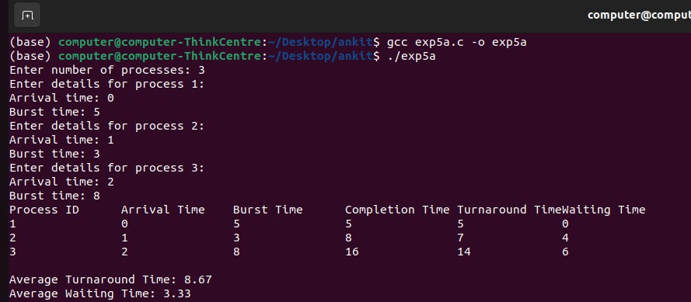

**AIM :** b) Write a program to demonstrate the concept of non-preemptive scheduling algorithm [SRTN].

# Program:

#include <stdio.h> #define MAX 10

struct Process { int id;

int arrival_time; int burst_time;

int remaining_time; int completion_time; int turn_around_time; int waiting_time;

};

int find_shortest_remaining_time(struct Process proc[], int n, int current_time) { int min_time = 9999;

int min_index = -1;

for (int i = 0; i < n; i++) {

if (proc[i].arrival_time <= current_time && proc[i].remaining_time > 0) { if (proc[i].remaining_time < min_time) {

min_time = proc[i].remaining_time; min_index = i;

}

}

}

return min_index;

}

void calculate_times(struct Process proc[], int n) { int total_turnaround_time = 0;

int total_waiting_time = 0; int current_time = 0;

int completed = 0;

while (completed < n) {

int idx = find_shortest_remaining_time(proc, n, current_time);

if (idx == -1) { current_time++; continue;

}

proc[idx].remaining_time--; current_time++;

if (proc[idx].remaining_time == 0) { proc[idx].completion_time = current_time;

proc[idx].turn_around_time = proc[idx].completion_time - proc[idx].arrival_time; proc[idx].waiting_time = proc[idx].turn_around_time - proc[idx].burst_time;

total_turnaround_time += proc[idx].turn_around_time; total_waiting_time += proc[idx].waiting_time; completed++;

}

}

printf("Process ID\tArrival Time\tBurst Time\tCompletion Time\tTurnaround Time\tWaiting Time\n"); for (int i = 0; i < n; i++) {

printf("%d\t\t%d\t\t%d\t\t%d\t\t%d\t\t%d\n",

proc[i].id, proc[i].arrival_time, proc[i].burst_time, proc[i].completion_time, proc[i].turn_around_time, proc[i].waiting_time);

}

printf("\nAverage Turnaround Time: %.2f\n", (float)total_turnaround_time / n); printf("Average Waiting Time: %.2f\n", (float)total_waiting_time / n);

}

int main() {

struct Process proc[MAX]; int n;

printf("Enter number of processes: "); scanf("%d", &n);

for (int i = 0; i < n; i++) {

printf("Enter details for process %d:\n", i + 1); proc[i].id = i + 1;

printf("Arrival time: "); scanf("%d", &proc[i].arrival_time); printf("Burst time: ");

scanf("%d", &proc[i].burst_time); proc[i].remaining_time = proc[i].burst_time;

}

calculate_times(proc, n);

return 0;

}

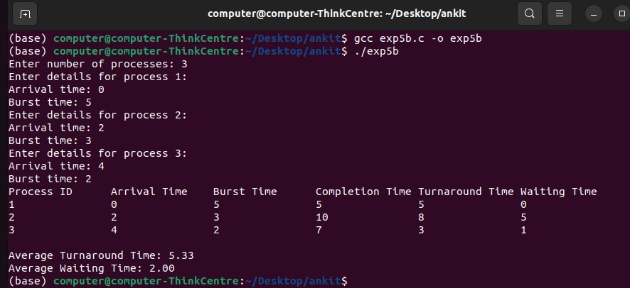**Output:**